Ansible Day 2



For Checking version of ansible

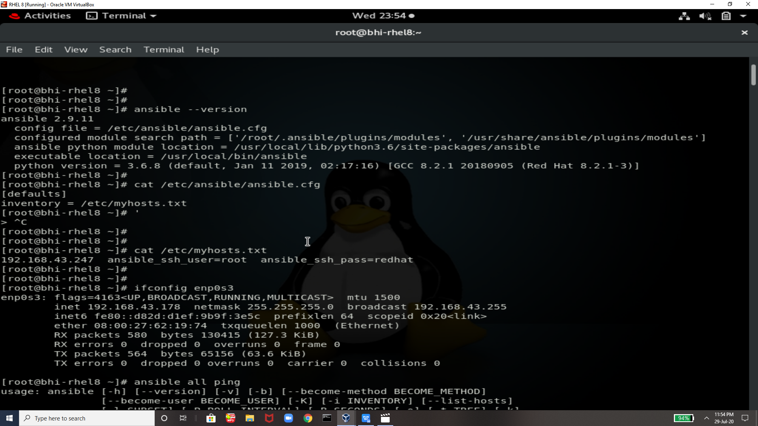

If u face any error like this then u can follow the comand to remvoe it I.e.  **export ANSIBLE_HOST_KEY_CHECKING=False**

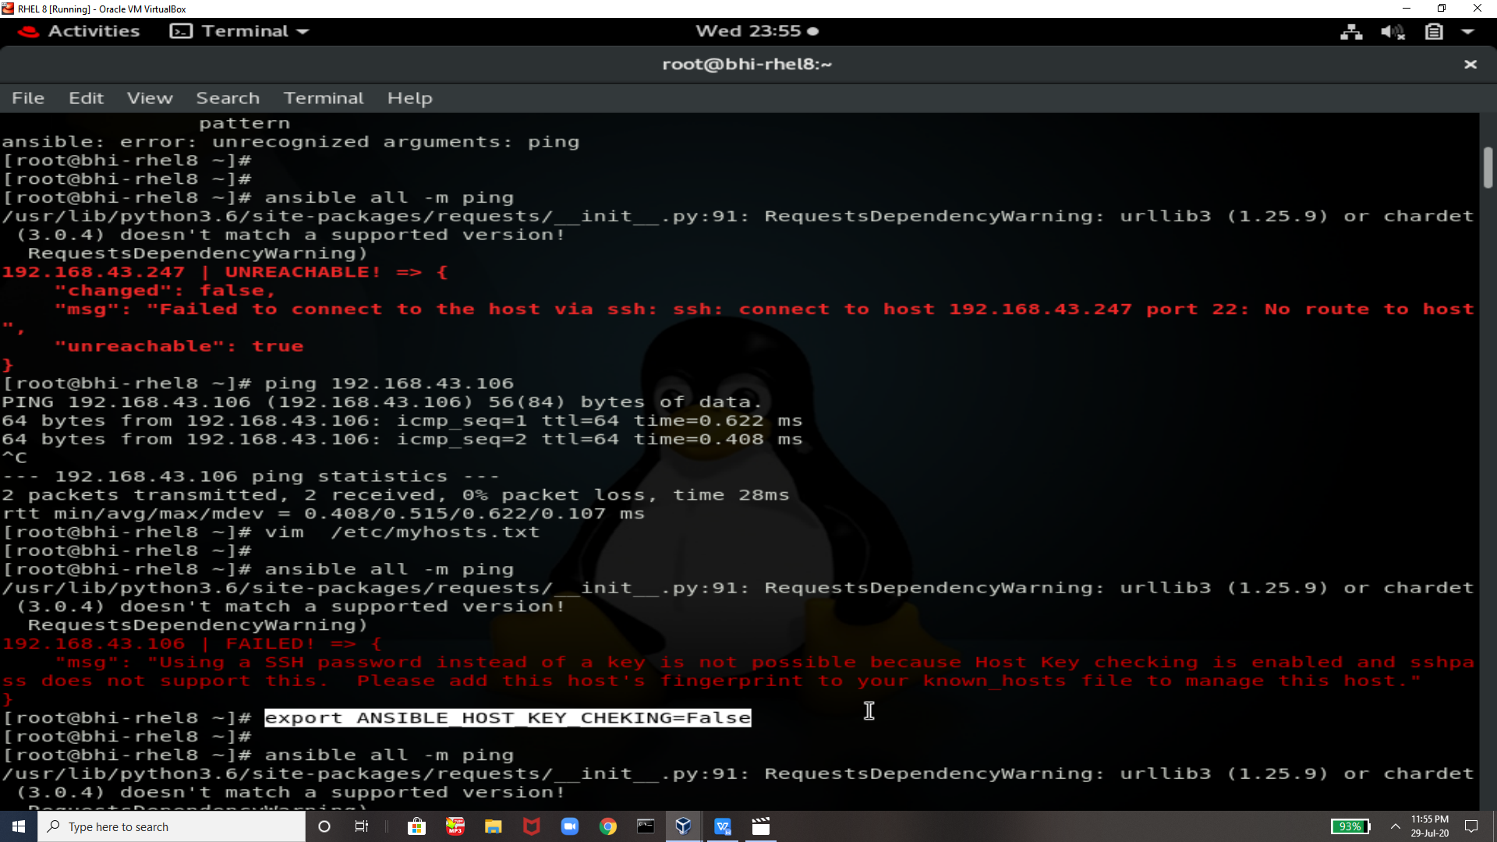

This command used to check ping that all the systems are pingable or not

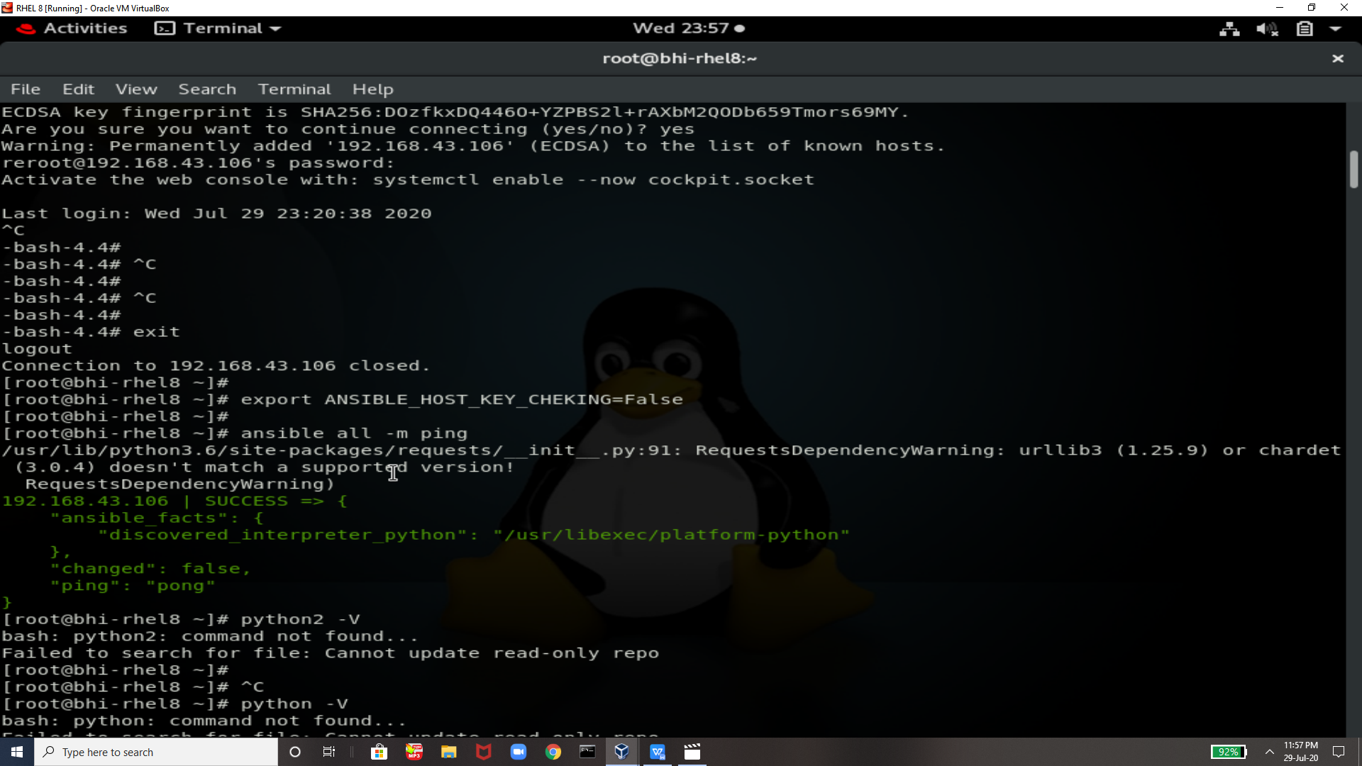

THis is our manage system means ansible target system !!

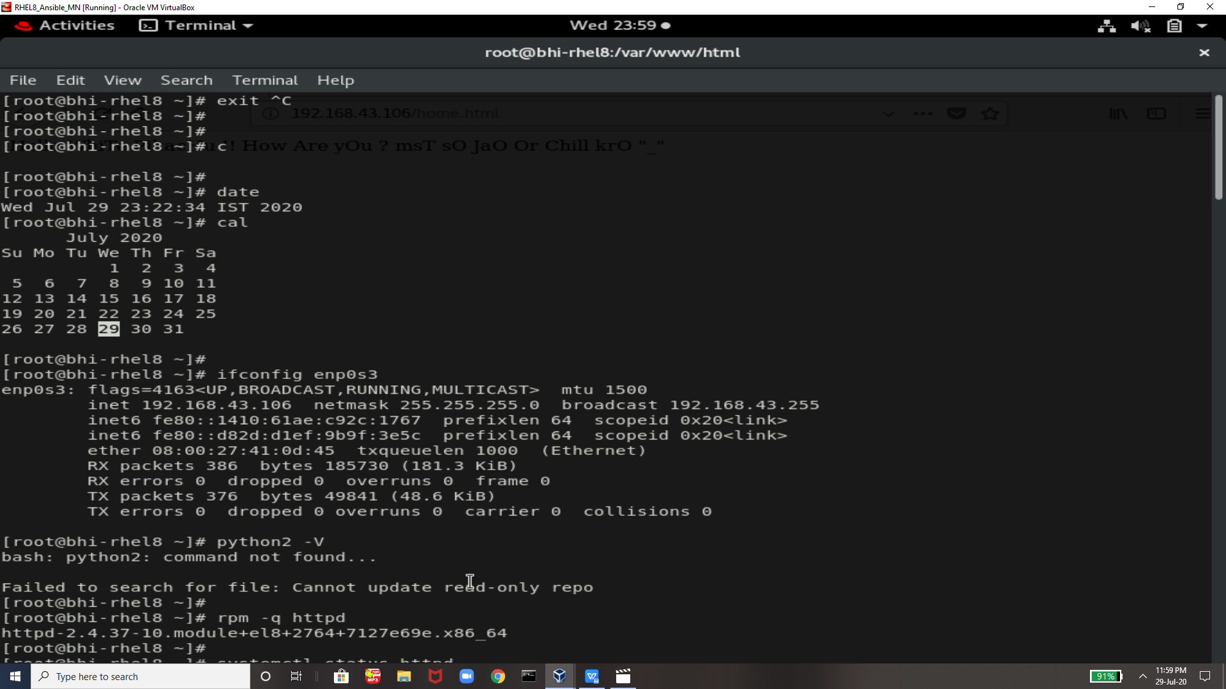

Checking in taeget system that httpd is already installed if yes then we need to remove this so we are removing this

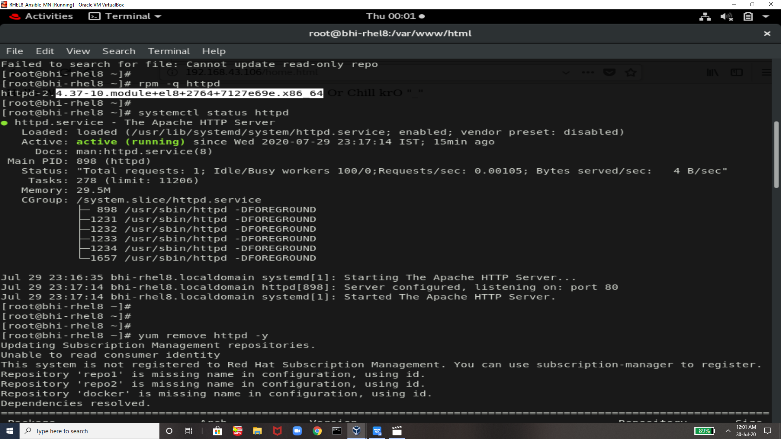

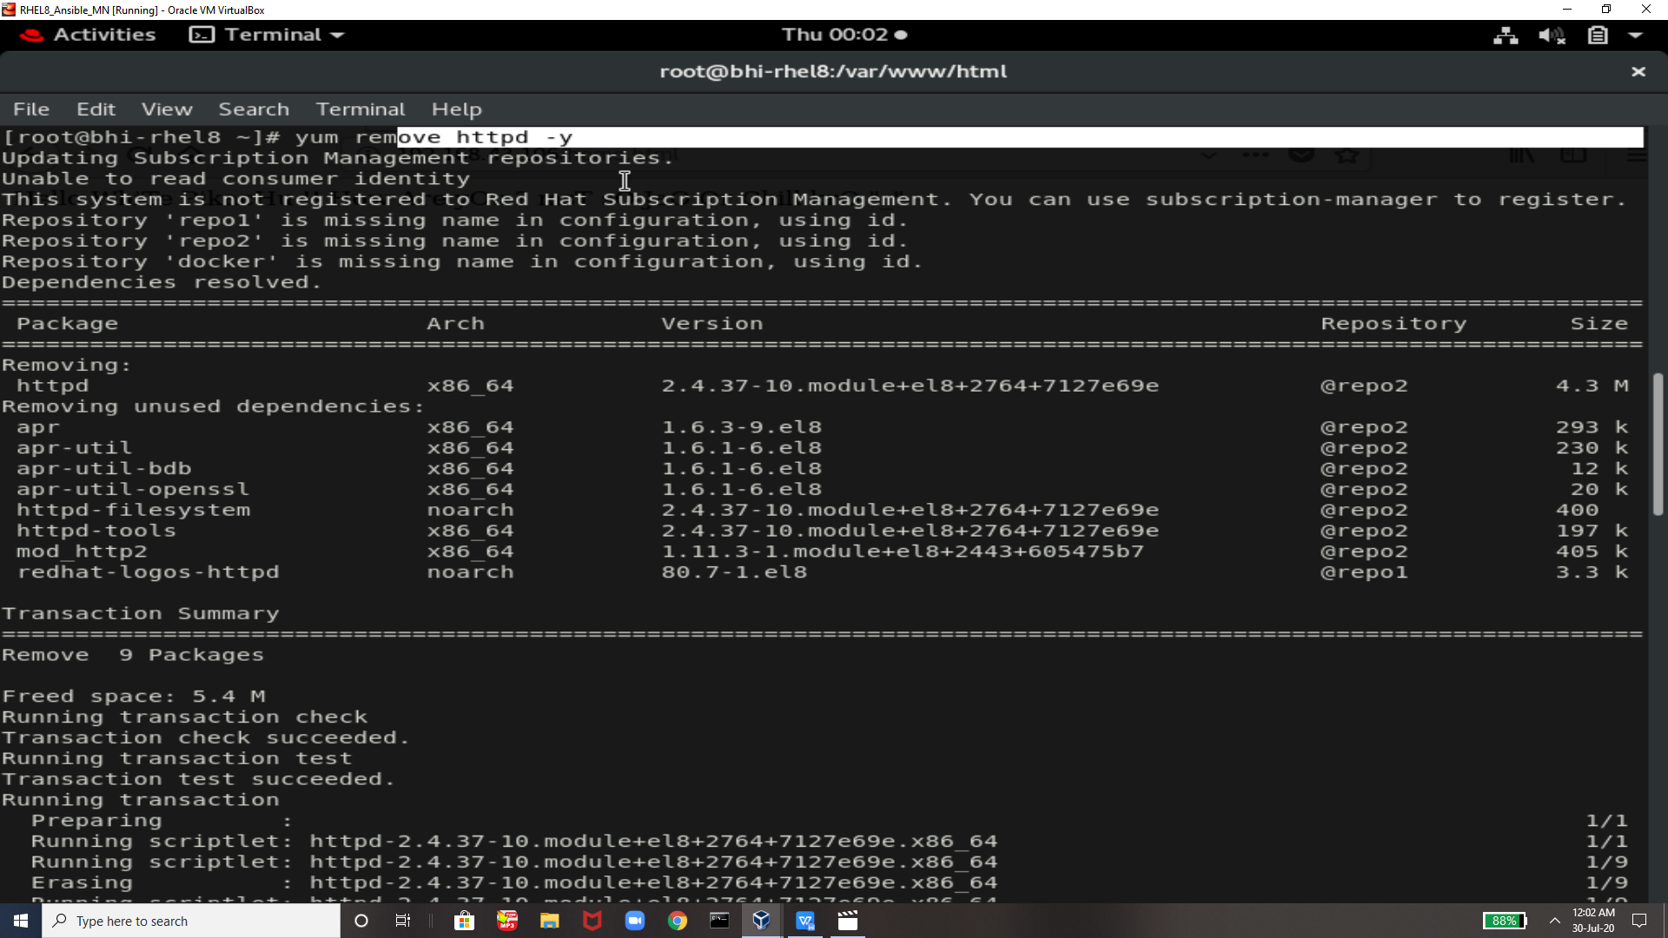

Now its completely removed

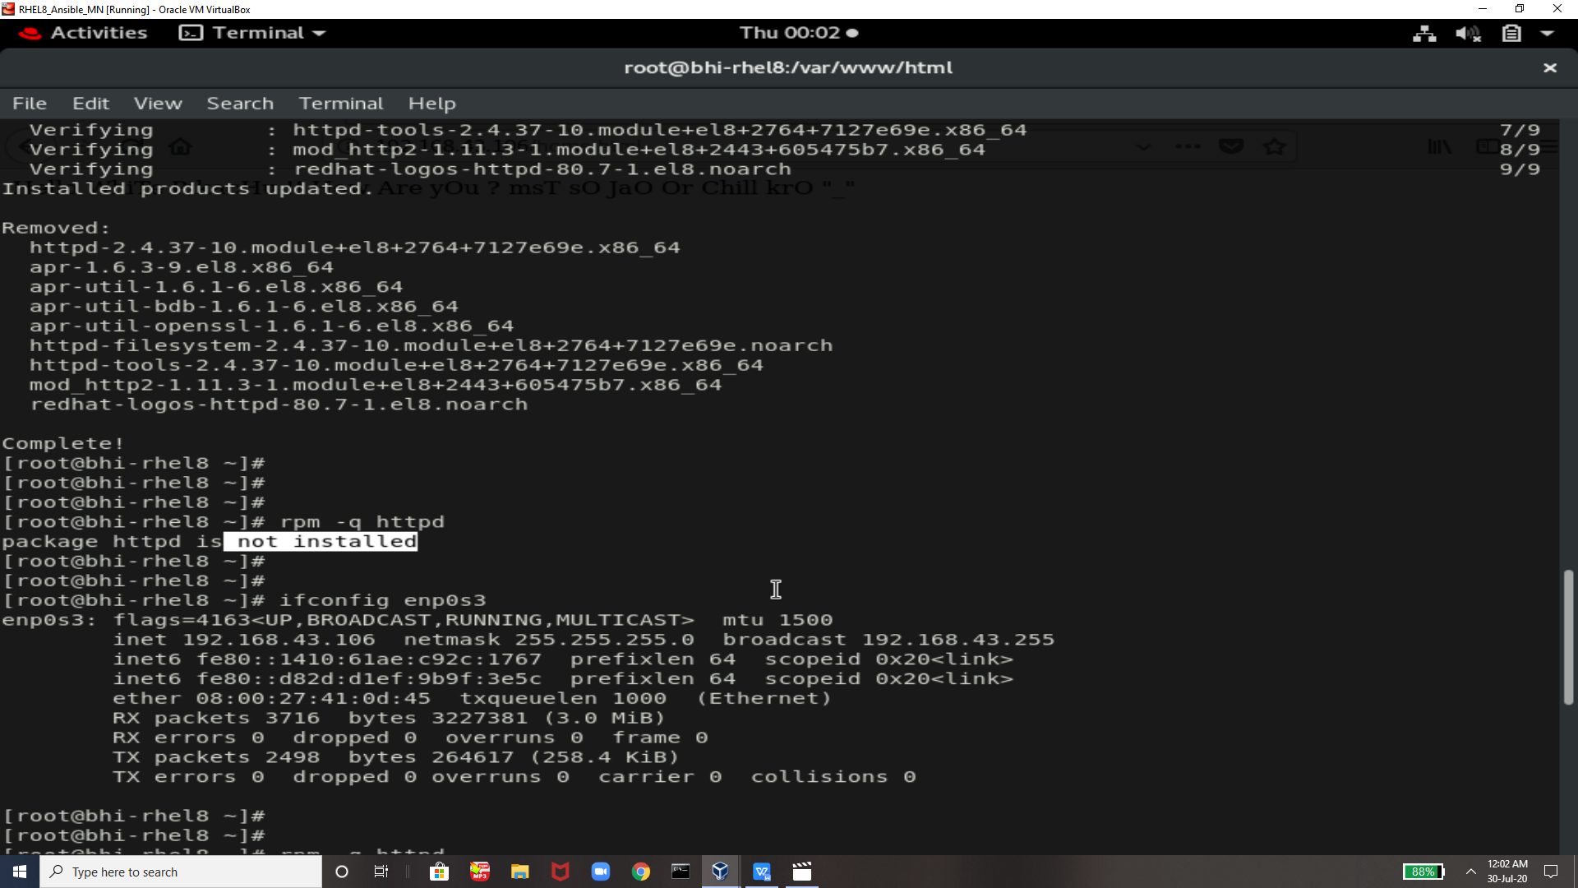

This command we will run from the controller system means where we have ansible installed

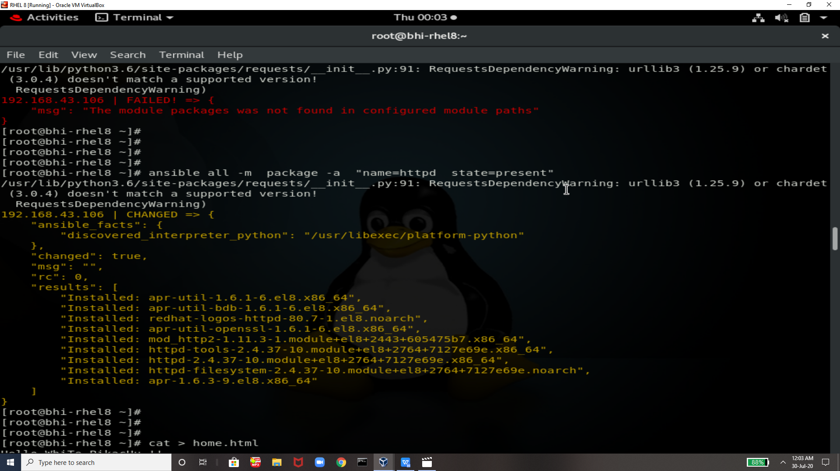

NOw u can see that without coming to this system httpd is installed in this system

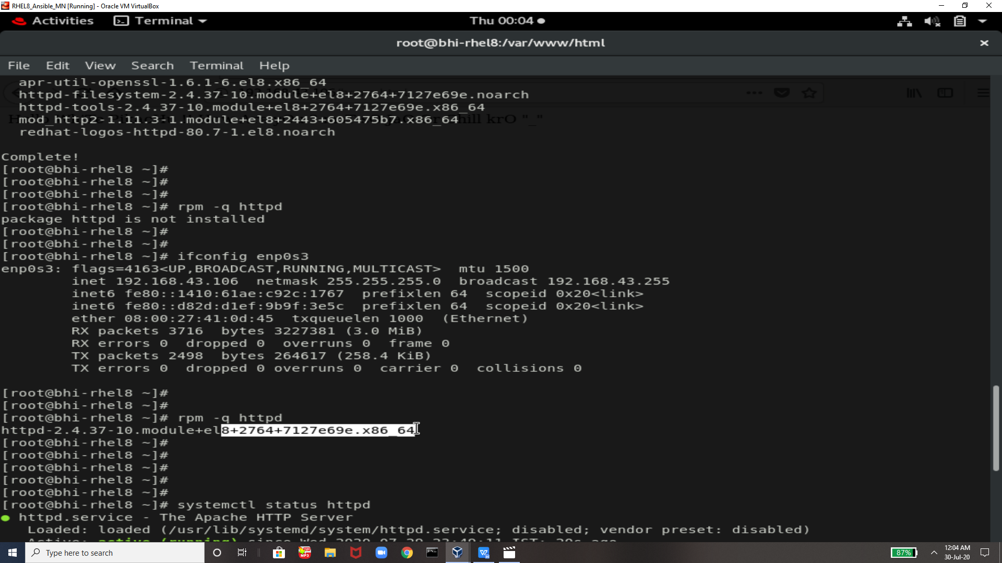

This command will copy the webpages from controller system to target system

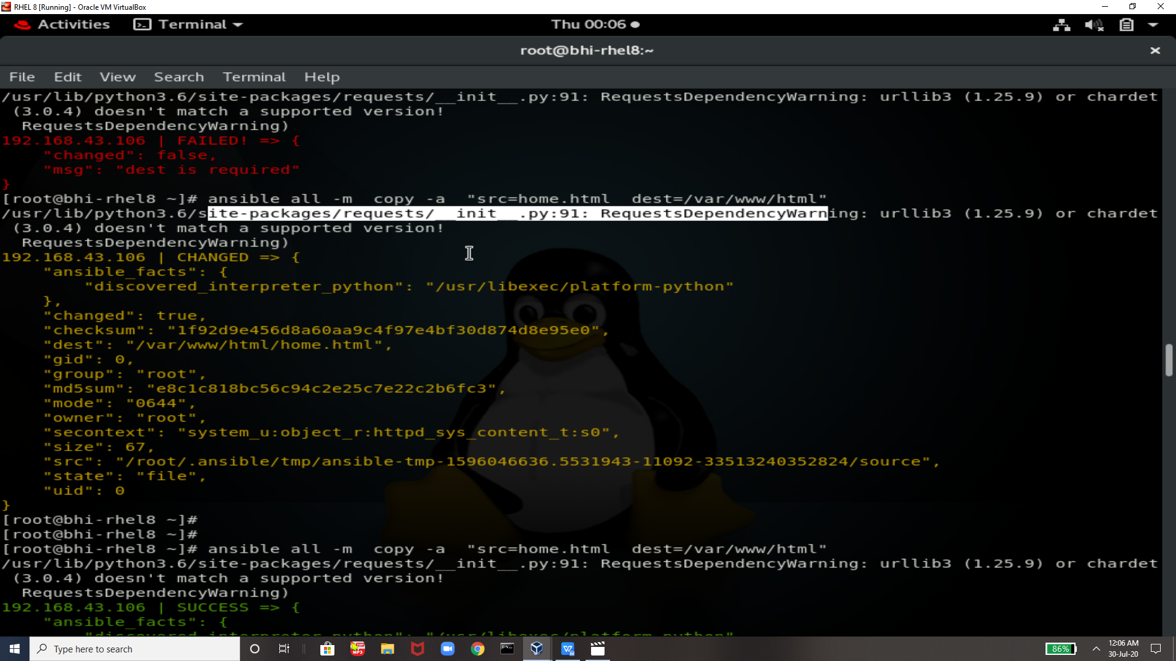

THis command will start httpd service from here means ansible system to the target system

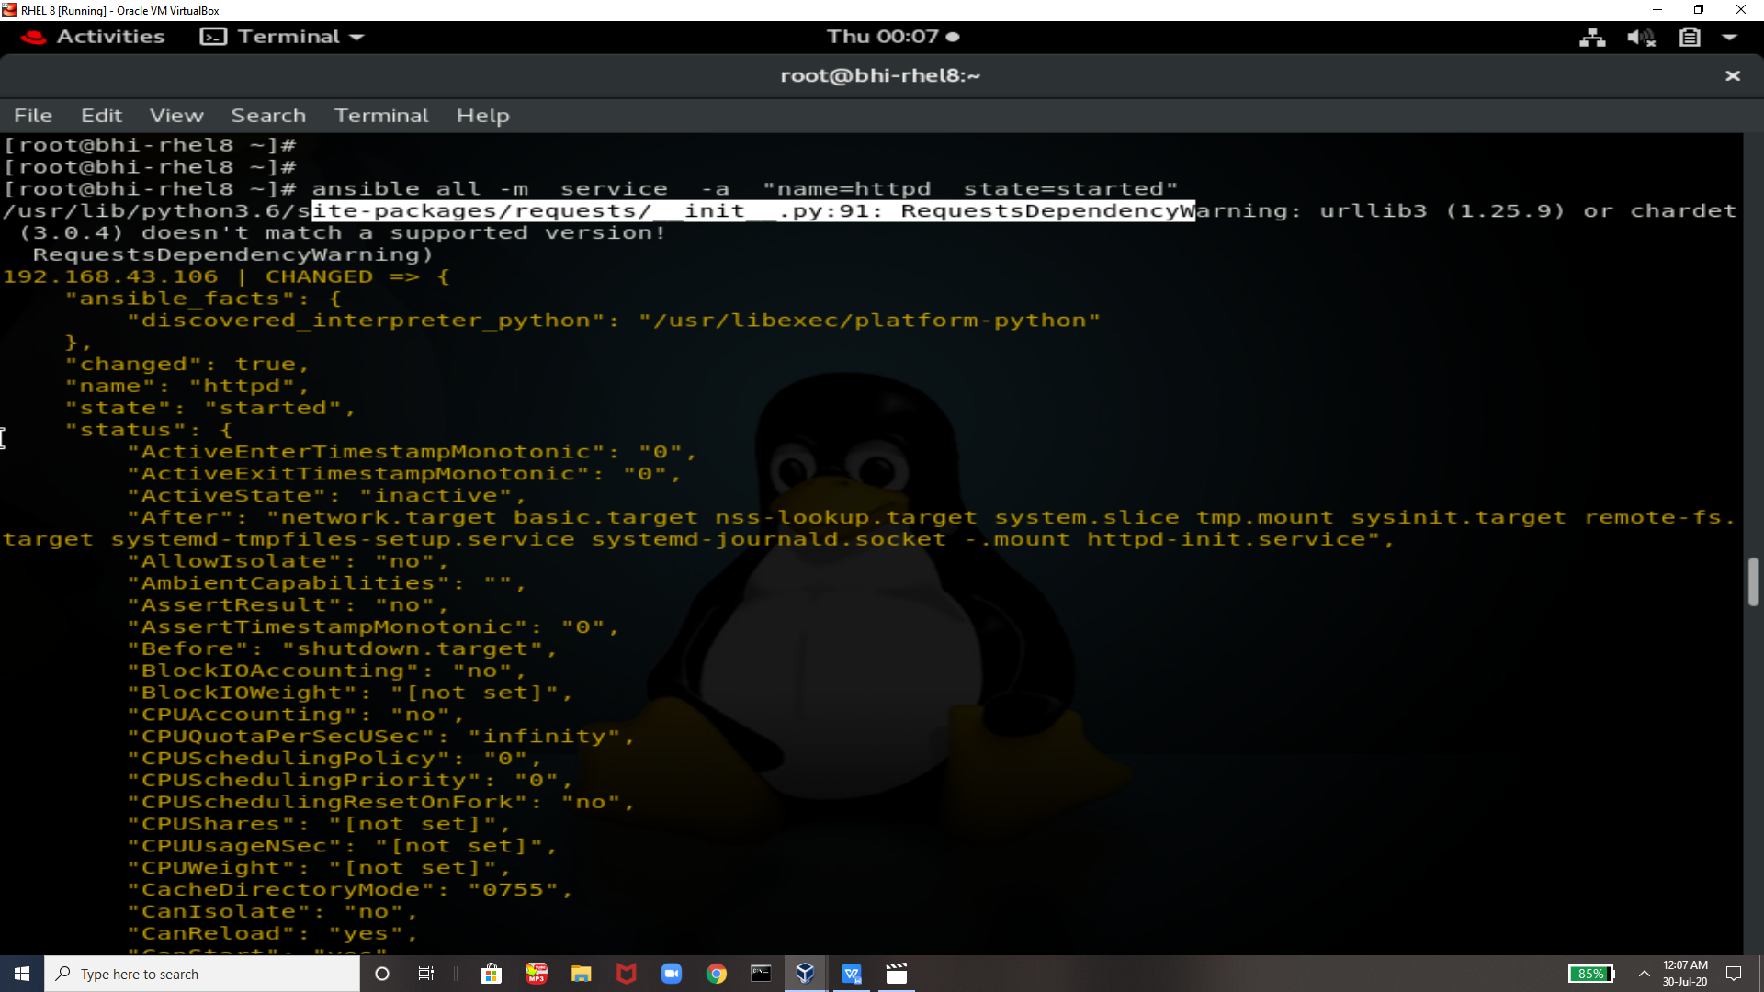

Now lets go to target system and check that the httpd service is started or not and the webpage file home.html is installed or not

So look its here and service is runnign

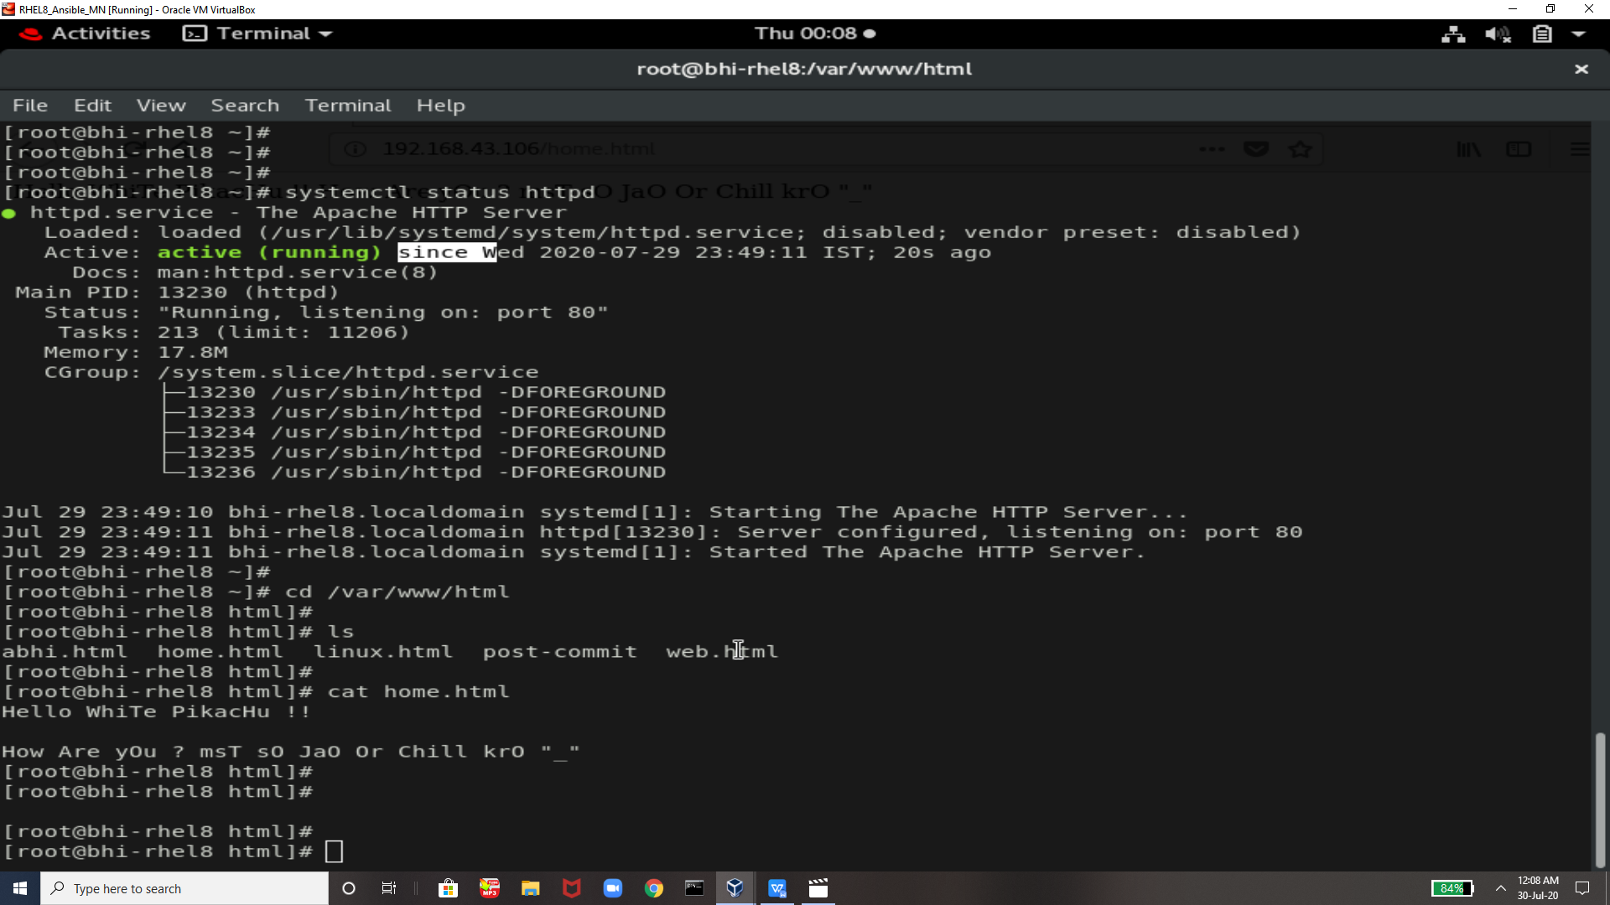

We can check by typing ip in the browser

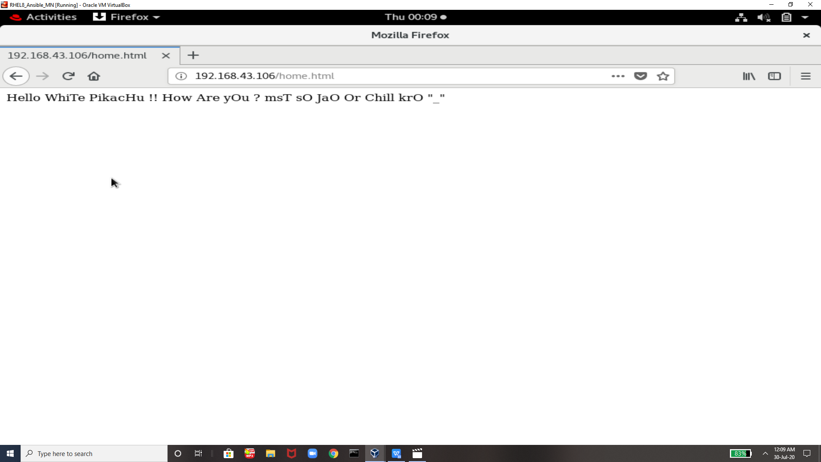

The command we use to do this is not automation so for achieving automation we will use ansible playbook



Need to create playbook ansible script to perform the same task using automation



THis is the script we need to write for this task

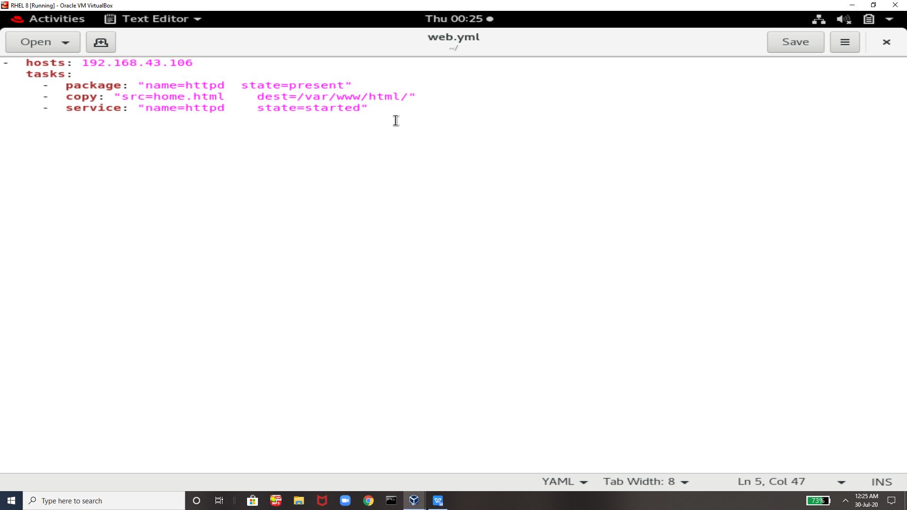

For chekong and running ansible playbool

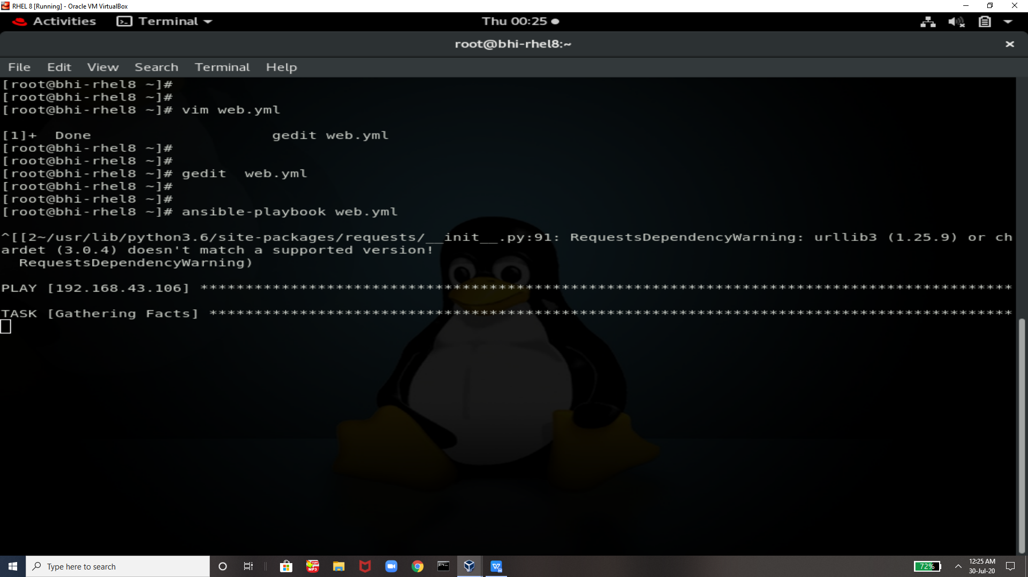

Now we have everything is installed in target system so its not doing anythign for us

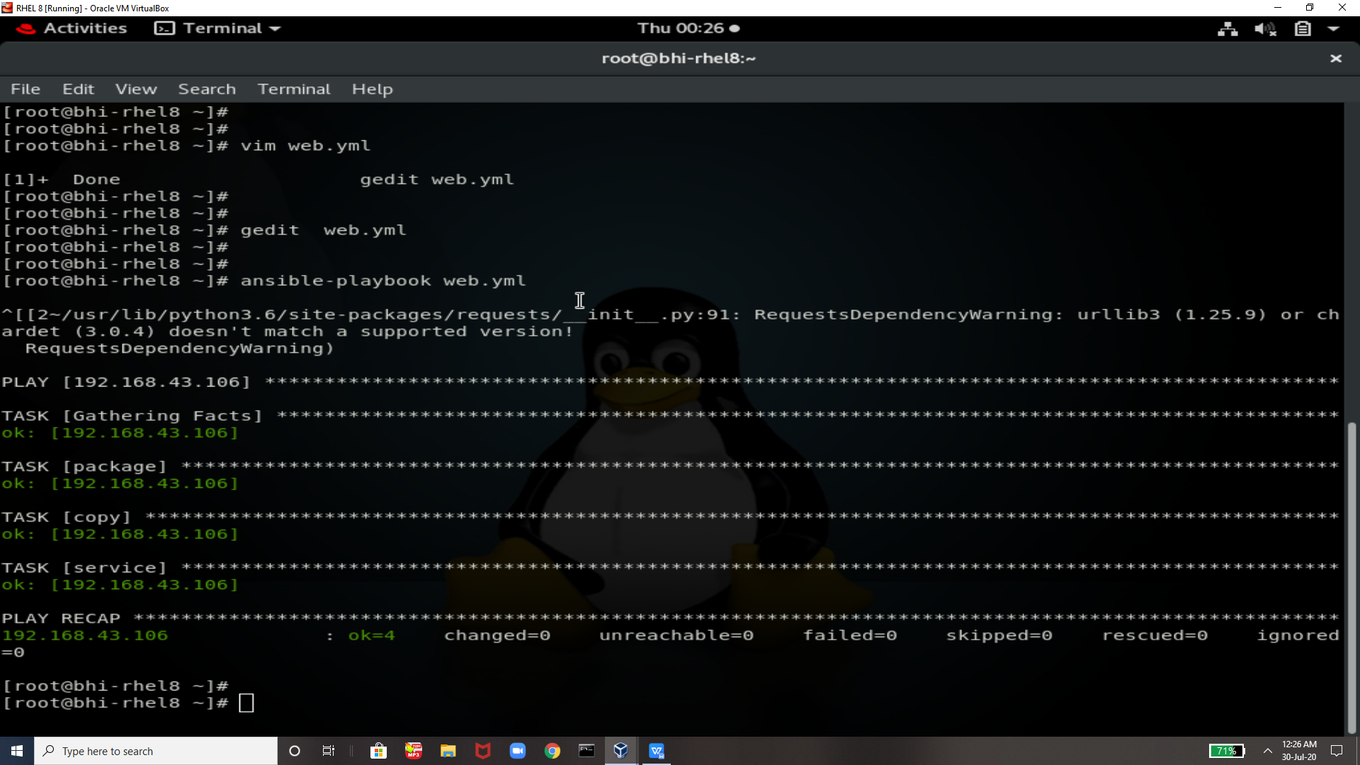

So lets remove everything and now lets see how ansible playbook will do this for us

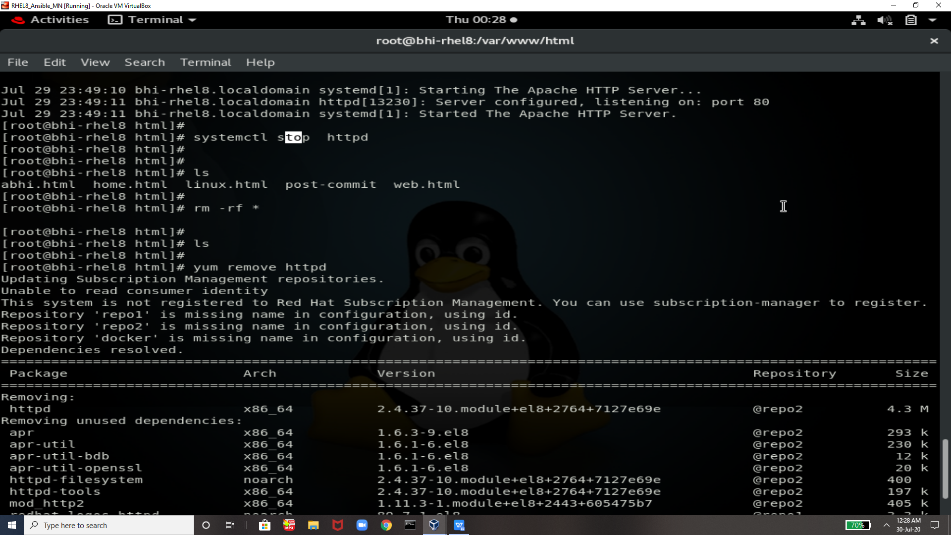

Look everything is uninstalled

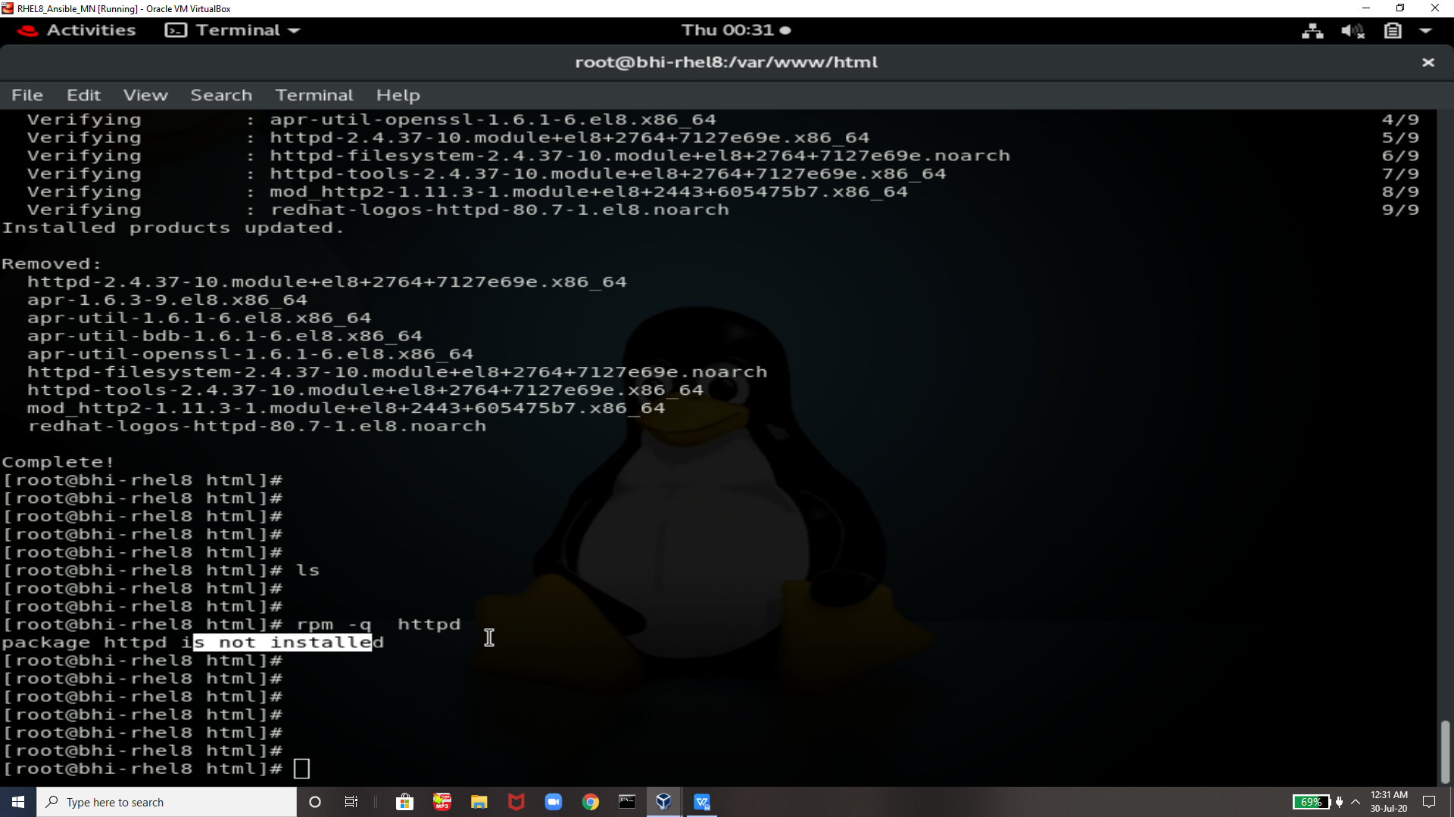

Now let see using ansible playbook

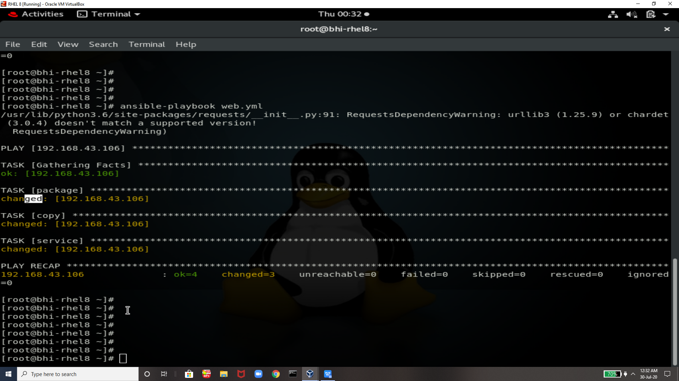

Look Everything is changed this means webserver is configured in target system just by using one command

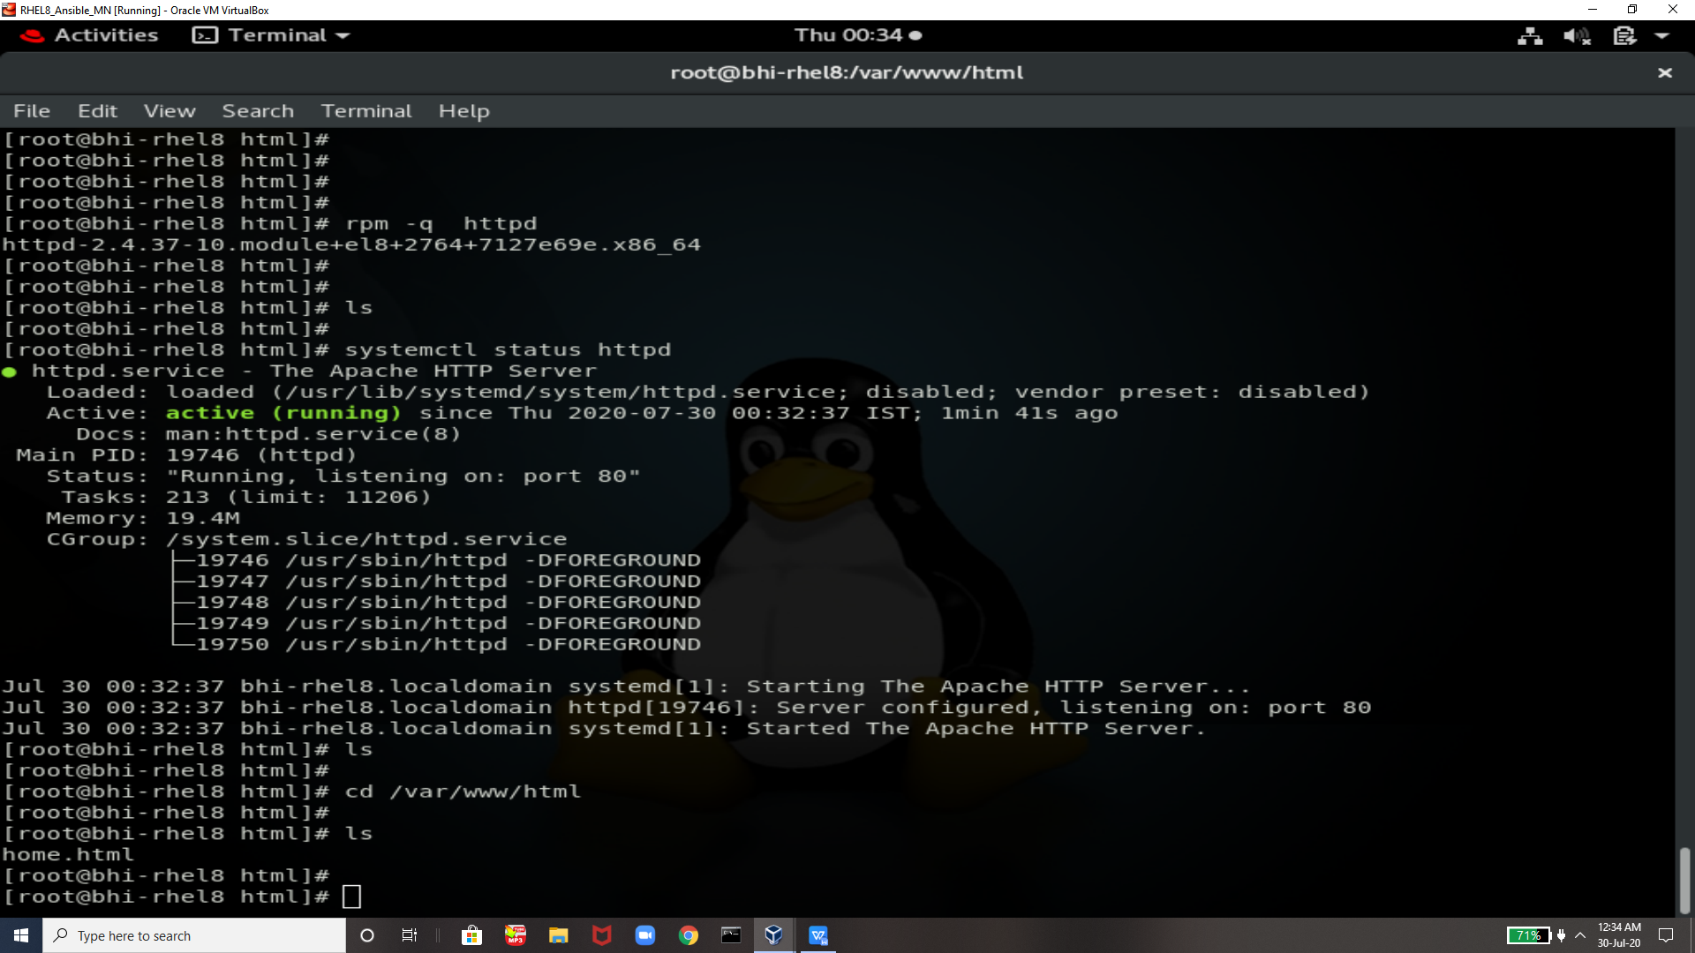

Everything is come up

Now we can again check with same means in browser

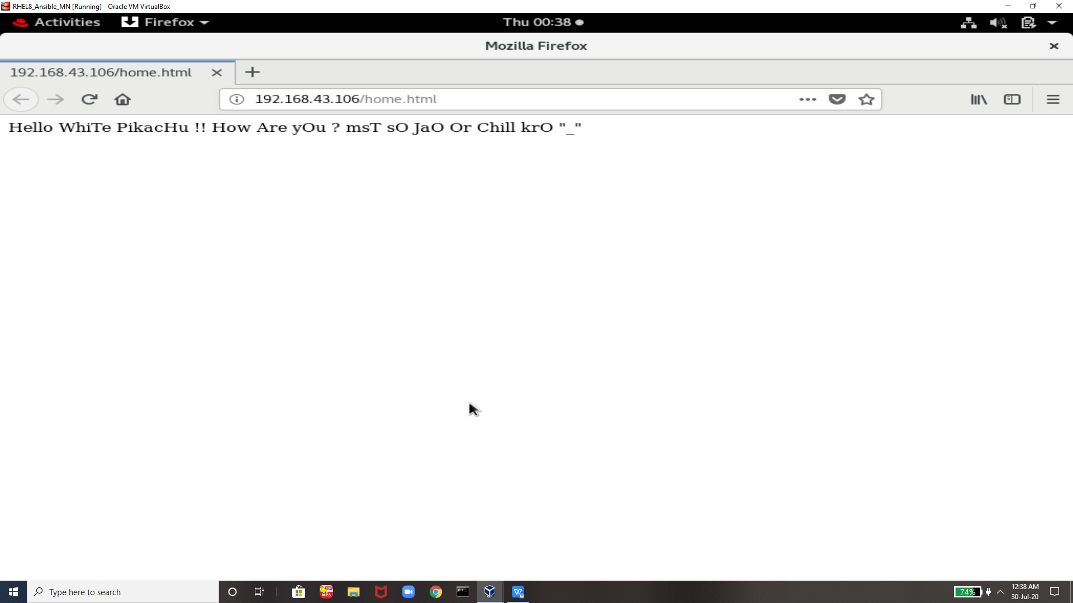



THanks vimal sir I am grooming my skills EveryDay ….!!

THanks yOu EveryOene For Reading !!!